PSGS-1618GF Gigabit PoE Switch

Quick Installation and
Initial Configuration

Contents
Chapter 1 Introduction 1
Overview 1
Front View of the Switch 1
Rear View of the Switch 1
LED Descriptions 2
Mode/Reset Button 4
Chapter 2 Installing the Switch 5
Package Contents 5
Mounting the Switch in a 19-inch Rack 5
Mounting the Switch on Desk or Shelf 6
Connecting the AC Power Cord 6
Installing SFP Modules 7
Chapter 3 Initial Configuration of Switch 8
Initial Switch Configuration Using Web Browsers 8
Initial Switch Configuration Procedure 8
Chapter 4 Troubleshooting 11

Chapter 1 Introduction

Overview
This user guide describes how to install, configure, and troubleshoot the PSGS-1618GF, 18 Ports PoE GbE Web Smart+ Switch.
By reading this user guide, users can perform the following tasks:
- To check the switch status by reading the LED behavior
- To reset the switch or to restore the switch to factory defaults
- To install the switch on the rack, on the wall, or on the desk
- To use a Web browser to initially configure the switch
- To troubleshoot the switch

Front View of the Switch

Figure 1: Front panel of the switch
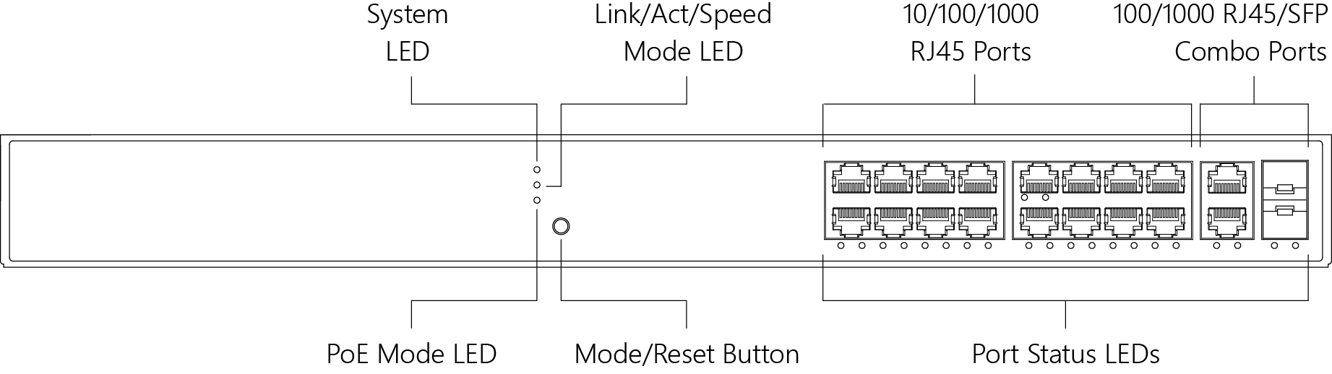

Rear View of the Switch

Figure 2: Rear panel of the switch

LED Descriptions

The LEDs on the front panel provide users with switch status checking and monitoring. There are three types of LEDs as follows:
- System LED indicates if the switch is powered up correctly or not, or, indicates if there is a system alarm triggered for troubleshooting.
- Mode LEDs indicates the mode of all RJ45/SFP ports on the switch. Users can press the Mode button sequentially to switch among the two different modes (Link/Activity/Speed mode and PoE mode).
- Port Status LEDs indicates the current status of each RJ45/SFP port. Users can check these LEDs to understand the port status in different modes, after changing the mode by pressing Mode button.

The following table details the functions and descriptions of various LED indicators.
Table 1: System LED
LED | Color | State | Description
System | Green | On | The switch is powered ON correctly.
 |  | Off | The switch is not receiving power.
 | Red | On | An abnormal state, such as exceeding operating temperature range, has been detected in the switch.

Table 2: Mode LEDs
LED | Color | State | Description
Link/Act/  Speed | Green | On | The RJ45/SFP Port Status LEDs are displaying  link status and network activity of each port, with connection speed of 1000Mbps.
 | Amber | On | The RJ45/SFP Port Status LEDs are displaying  link status and network activity of each port, with connection speed of 10/100Mbps.
PoE | Green | On | The RJ45 Port Status LEDs are displaying  PoE powering status of each port.

Table 3: Port Status LEDs
By pressing the MODE button in less than 2 seconds to change LED modes (Link/Act/Speed Mode or PoE Mode), users can check the port status by reading the LED behaviors per the table below.
When Link/Act/Speed Mode LED Lit
LED | Color | State | Description
RJ45 Ports | Green | On | The port is enabled and established a link to connected device, and the connection speed is 1000Mbps.
 | Green | Blinking | The port is transmitting/receiving packets, and the connection speed is 1000Mbps.
 | Amber | On | The port is enabled and established a link to connected device, and the connection speed is 10/100Mbps.
 | Amber | Blinking | The port is transmitting/receiving packets, and the connection speed is 10/100Mbps.
 | -- | Off | The port has no active network cable connected, or it is not established a link to connected device. Otherwise, the port may have been disabled through the switch user interface.
SFP Ports | Green | On | The port is enabled and established a link to connected device, and the connection speed is 1000Mbps.
 | Green | Blinking | The port is transmitting/receiving packets, and the connection speed is 1000Mbps.
 | Amber | On | The port is enabled and established a link to connected device, and the connection speed is 100Mbps.
 | Amber | Blinking | The port is transmitting/receiving packets, and the connection speed is 100Mbps.
 | -- | Off | The port has no active network cable connected, or it is not established a link to connected device. Otherwise, the port may have been disabled through the switch user interface.
When PoE Mode LED Lit
LED | Color | State | Description
RJ45 Ports | Green | On | The port is enabled and supplying power to connected device.
 | Amber | On | An abnormal state, such as overload status, has been detected in the switch.
 | -- | Off | The port has no active network cable connected, or it is not connected a PoE PD device. Otherwise, the port may have been disabled through the switch user interface.

Mode/Reset Button
By pressing the Mode/Reset Button for certain period of time, users can perform the following tasks.
- Change Port Status LED Mode to read the port status correctly in the two different modes (Link/Act/Speed mode or PoE mode).
- Reset the Switch to reboot and get the switch back to the previous configuration settings saved.
- Restore the Switch to Factory Defaults to restore the original factory default settings back to the switch.
Note: According to the table below, users can easily judge which task is being performed by reading the LED behaviors while pressing the Mode/Reset button. Once the LED behaviors are correctly displayed, users may just release the button.

Table 4: Mode/Reset Button Descriptions
Task to be  Performed | Time Period of Pressing Button | SYS LED  Behavior | Port Status LED  Behavior
Change LED Mode | 0 ~ 2 seconds | ON  Green | LED status will be changed according the mode selected.
Reset the Switch | 2 ~ 7 seconds | Blinking  Green | ALL LEDs  Light OFF
Restore to Defaults | 7 ~ 12 seconds | Blinking  Green | ALL LEDs  Stay ON

Chapter 2 Installing the Switch

Package Contents
- The Switch
- AC Power cord
- Four adhesive rubber feet
- Installation Guide
- Mounting kit
Note:
The switch is an indoor device. If you need to use it to connect outdoor devices such as outdoor IP cameras or outdoor WiFi Aps with cable, then you need to install an arrester on the cable between outdoor device and the switch.
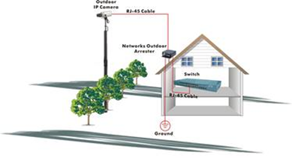
Fig. Addition an arrester between outdoor device and this switch

Mounting the Switch in a 19-inch Rack

Step 1: Attach the mounting brackets to both sides of the chassis. Insert screws and tighten then with a screwdriver to secure the brackets.

Figure 3: Attaching Brackets to the Switch
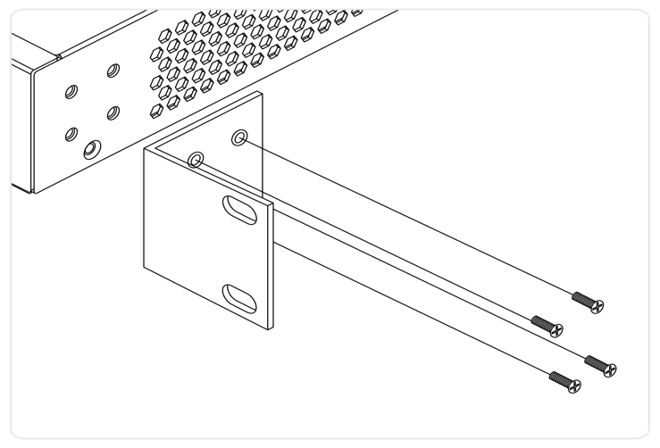

Step 2: Place the switch on a rack shelf in the rack. Push it in until the oval holes in the brackets align with the mounting holes in the rack posts.
Step 3: Attach the brackets to the posts. Insert screws and tighten them.

Figure 4: Attaching Brackets to the Rack Post
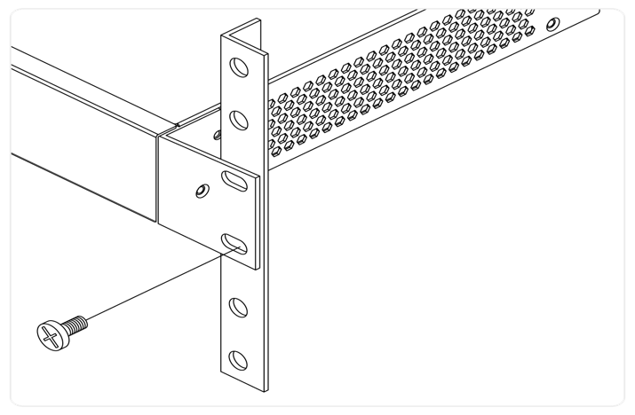

Mounting the Switch on Desk or Shelf
Step 1: Verify that the workbench is sturdy and reliably grounded.
Step 2: Attach the four adhesive rubber feet to the bottom of the switch.

Figure 5: Attaching the Rubber Feet
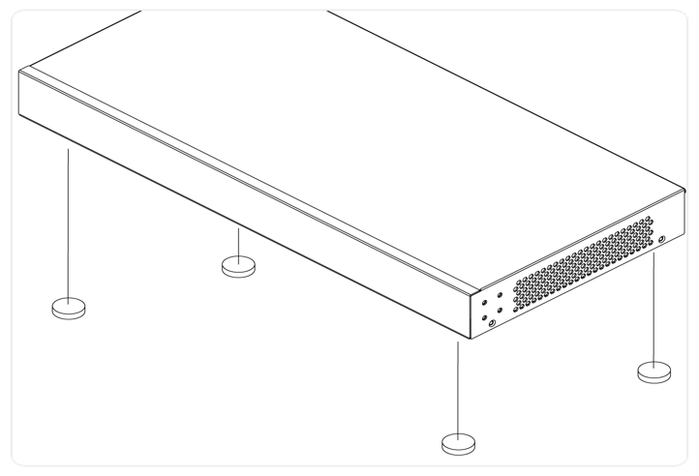

Connecting the AC Power Cord
Step 1: Connect the AC power cord to the AC power receptacle of switch.
Step 2: Connect the other end of the AC power cord to the AC power outlet.
Step 3: Check the SYS LED. If it is ON, the power connection is correct.
Figure 6: Connecting AC power cord
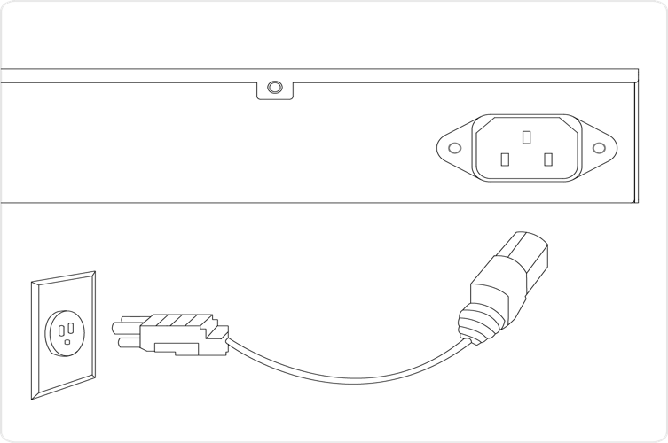

Installing SFP Modules
You can install or remove a mini-GBIC SFP module from a SFP port without having to power off the switch.
Step 1: Insert the module into the SFP port.
Step 2: Press firmly to ensure that the module seats into the connector.
Figure 7: Installing a SFP Module into a SFP Port
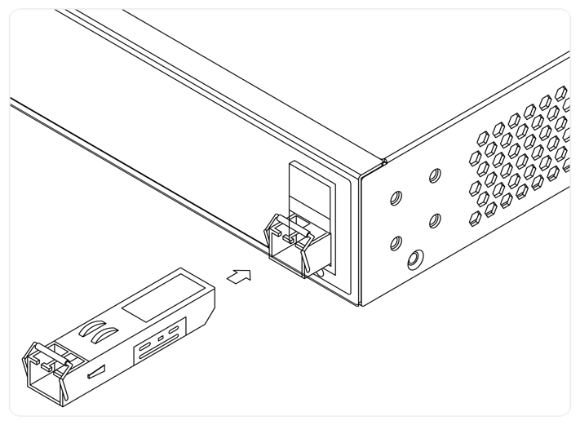

Chapter 3 Initial Configuration of Switch

Initial Switch Configuration Using Web Browsers

After powering up the switch for the first time, you can perform the initial switch configuration using a web browser. For managing other switch features, please refer to the Web interface user guide for details.

To begin with the initial configuration stage, you need to reconfigure your PC’s IP address and subnet mask so as to make sure the PC can communicate with the switch. After changing PC’s IP address (for example, 192.168.1.250), then you can access the Web interface of the switch using the switch’s default IP address as shown below.

Note: The factory default IP address of the switch is 192.168.1.1
The factory default Subnet Mask of switch is 255.255.255.0

Initial Switch Configuration Procedure

The initial switch configuration procedure is as follows:

- Power up the PC that you will use for the initial configuration. Please make sure the PC has the Ethernet RJ45 connector to be connected to the switch via standard Ethernet LAN cable.

- Reconfigure the PC’s IP address and Subnet Mask as below,
so that it can communicate with the switch. The method to change the PC’s IP address, for example, for a PC running Windows® 7/8.x/10, is as follows:

Step 1: Type “network and sharing“ into the Search box in the Start Menu
Step 2: Select Network and Sharing Center
Step 3: Click on Change adapter settings on the left of PC screen

Note: Users can also skip step 1 to 3, by pressing WinKey+R and type ”ncpa.cpl” command to get to step 4 directly.

Step 4: Right-click on your local adapter and select Properties
Step 5: In the Local Area Connection Properties window highlight Internet Protocol Version 4 (TCP/IPv4) then click the Properties button.

Note: Be sure to record all your PC’s current IP settings to be able to restore them later.

Step 6: Select the radio button Use the following IP address and enter in the IP for the PC (e.g. any IP address not in use, and in between 192.168.1.2 and 192.168.1.254), Subnet mask (e.g. 255.255.255.0), and Default gateway that corresponds with your network setup. Then enter your Preferred and Alternate DNS server addresses.
Step 7: Click OK to change the PC’s IP address.

- Power up the switch to be initially configured, and wait until it has finished its start-up processes.

- Connect the PC to any port on the switch using a standard Ethernet cable, and check the port LED on the switch to make sure the link status of the PC’s is OK.

- Run your Web browser on the PC, enter the factory default IP address, so as to access the switch’s Web interface.
If your PC is configured correctly, you will see the login page of the switch as shown by Figure 9 below.

Figure 9: Web Interface login page
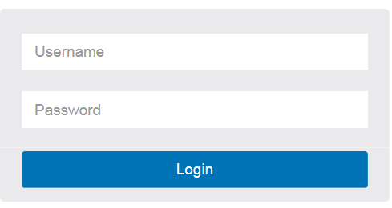

If you do not see the above login page, please perform the following steps:
- Refresh the web page.
- Check to see if there is an IP conflict issue.
- Clean browser cookies and temporary internet files.
- Check your PC settings again and repeat step 2.

- Enter the factory default username and password in login page.
Click “Login” to log into the switch.

Note: The factory default Username of the switch is admin
There is no factory default Password of the switch.

Chapter 4 Troubleshooting
The following table provides information for users to easily troubleshoot problems by taking actions based on the suggested solutions within.
Table 5: Troubleshooting Table
Symptoms | Possible Causes | Suggested Solutions
SYSTEM LED is Off | The switch is not receiving power. | 1. Check if correct power cord is connected firmly to the switch and to the AC outlet socket.  2. Perform power cycling the switch by unplugging and plugging the power cord back into the switch.  3. If the LED is still off, try to plug power cord into different AC outlet socket to make sure correct AC source is supplied.
SYSTEM LED is RED | An abnormal state has been detected by the switch. | Check the system log within the switch from WEB UI to understand the abnormal state (e.g. exceeding operating temperature range) and take corresponding actions to resolve.
Port Status LED is Off in the Link/Act/Speed Mode | The port is not connected or the connection is not working. | 1. Check if the cable connector plug is firmly inserted and locked into the port at both the switch and the connected device.  2. Make sure the connected device is up and running correctly.  3. If the symptom still exists, try different cable or different port, in order to identify if it is related to the cable or specific port.  4. Check if the port is disabled in the configuration settings via WEB user interface .
Port Status LED is Off in the  PoE Mode | The port is not supplying power | 1. Check if the cable connector plug is firmly inserted and locked into the port at both the switch and the connected device.  2. Make sure the correct Ethernet cables are used.  3. If the symptom still exists, try different cable or different port, in order to identify if it is related to the cable or specific port.  4. Check if the port is disabled in the configuration settings via WEB user interface .

